**MISSING SHIP DETECTION ON WATER BODIES**

DR.D.Durga Bhavani

Assistant Professor

Department of Computer Science and Engineering

Institute of aeronautical Engineering, Dundigal

Hyderabad

Esramoni Mounika

Department of Computer Science and Engineering

Institute of Aeronautical Engineering , Dundigal

Hyderabad

A Maheshwara Vishwa Nethra

Department of Computer Science and Engineering

Institute of Aeronautical Engineering, Dundigal

Hyderabad

K. Jayanth Sai

Department of Computer Science and Engineering

Institute of Aeronautical Engineering , Dundigal

Hyderabad

***Abstract***— States are becoming more and more dependent on the efficient use and management of marine channels for military and commercial purposes. Several reasons underlie this goal: ensuring that ships navigate narrow canals safely; preventing the unauthorised use of ship anchoring areas; keeping an eye on fishing activities to prevent illegal fishing or protect fish populations; locating lost ships, boats, or debris in the ocean; and locating and identifying warships (offensive, defensive, intelligence, etc.). This study presented a deep learning algorithm-based, open-source, quick ship detection method using optical satellite pictures. The system may operate on a typical laptop and doesn't require any sophisticated hardware. The Application Programming Interface (API) for Tensor flow Object Detection is learned using optical satellite photos of ships..

.

***Keywords****—* *Artificial neural networks, tensorflow, python, optical satellite images, and ship detection*

I. INTRODUCTION

States are finding that they increasingly need to effectively employ and control marine channels in the commercial and military domain. The number of ships and their size are growing every day due to the shipbuilding industry's explosive growth. Safe passage is seriously threatened by this, particularly in congested areas. Although some ports designate specific anchorages and evacuation routes to guarantee the security of cruises falling within this scope, regular ships are free to utilise these channels and anchorages without authorization. Additionally, fishing vessels may occasionally erratically occupy the main canals as fishing zones, which is another form of illegal use [1]. Ship detection has increased as a result of the global loss in fish reserves.

The observer can directly examine these places by travelling there, but doing so will take time, and there will be a significant risk in the event of terrorism or war. Right now, "remote sensing" provides an excellent remedy. Radar, video cameras, optical satellite images, and synthetic aperture radar (SAR) imagery can all be used to examine the sea's surface. Active transmission devices can be risky for observers during a fight since they allow enemy electronic warfare weapons to determine your coordinates based on what you transmit. This is never desirable in a combat zone. in order to increase the usefulness of gadgets like satellite imagery and video cameras. The video cameras' field of view and viewing distance are smaller than those of satellite imaging systems.

SAR photography is far more helpful at night than optical satellite imagery because it doesn't require a lightning source, however it typically produces images with high-level speckles

By training the Tensorflow Object Detection API, this work aims to provide an extra alternative to the ship detection algorithms from optical satellite imagery. Figure 4 depicts artificial neural networks (ANN). There are three layers in it: input, concealed, and output. The hidden layer is the layer that has the greatest influence on the network's capacity for learning, even though each layer can contain several neurons. In machine learning, convolutional neural networks (CNNs) are deep feed artificial neural networks that have been effectively used for image processing. It is a multilayer network design that was created using the traditional neural network methodology. An input layer, convolution layer, pooling layer, complete connection layer, and output layer are typically found in a CNN. It is frequently used for classification and estimation because of its quick learning curve, excellent prediction accuracy, and ability to carry out feature extraction and mapping.

II . PREVIOUS WORK

The regional shape feature (eigenvalues) of ship video camera images were extracted by Du et al. [1] using Hu invariant moments and ART coefficients. The selected features were then matched with a ship feature library using the K-Nearest Neighbour (KNN) approach. Based on the most comparable eigenvalue in the collection, ships were categorised. Zhu et al.'s research [2] has focused on ship detection using space-based optical imagery. The negative effects of clouds, waves in the ocean, and small islands are eliminated through the application of semi-supervised hierarchical classification, image segmentation, and basic shape analysis. A tiny boat identification method developed by Yaman and Asari [3] uses both the visible and infrared bands to identify boats in heavily congested backdrop video camera images. For IR, they employ the Graph-cut segmentation.

Ultimately, the fusion approach is employed to merge the candidates. Be binar and Alatan [9] created an optical satellite image-based approach for ship detection in the coastal zone. The normalised difference water index (NDWI) was thresholded using the zero level of the most recent global elevation data to provide an initial mask. The graph-cut algorithm further improved the segmentation result's limit. Line segments that represented artificial ports were found using the resulting boundary line. These line segments were utilised to remove the port area after being appropriately merged and deleted; as a result, the remaining portions of the binary mask were tested as ships based on their shapes. The texture-based ship categorization algorithm in the optical satellite image was developed by Arguedas [10]. He split the ship in two.

## III. MACHINE LEARNING

Artificial Neural Networks (ANN) are a type of architecture used in several deep learning techniques; Fig. 4. There are three layers in it: input, concealed, and output. The hidden layer is the layer that has the biggest influence on the network's capacity for learning, even though each layer can contain several neurons [14].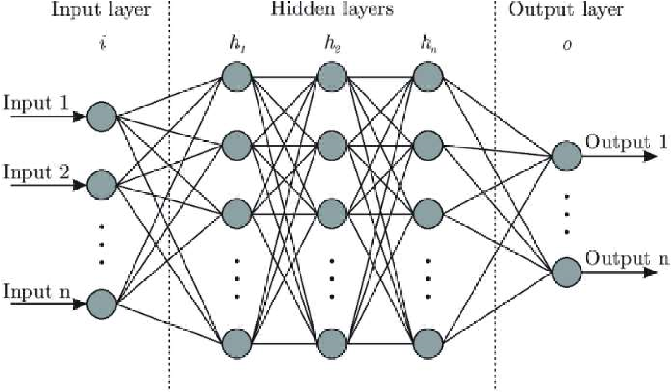

Fig. 4. Artificial Neural Network

In machine learning, convolutional neural networks (CNNs) are deep feed artificial neural networks that have been effectively used for image processing. It is a multilayer network design that was created using the traditional neural network methodology. An input layer, convolution layer, pooling layer, complete connection layer, and output layer are typically found in a CNN. It is frequently used for classification and estimation because of its quick learning curve, excellent prediction accuracy, and ability to carry out feature extraction and mapping.. [15].

## IV. SHIP DETECTION METHOD

The goal of the ship detection method's design was to create a system that would be simple to use, operate rapidly, and have open source code. Libraries and programming languages are discussed in the Appendix.

Even with a GPU, training a single object detection model might take weeks or months. It will take the CPU a lot longer to complete. Thus, it is far more practical and time-saving to use a pre-trained model and train it for the object (in this case, a ship). For an object detection model that has already been trained, Tensorflow Object Detection Application Programming Interface (API) trained by Google is utilised. To detect the ships, it is trained using optical satellite pictures.

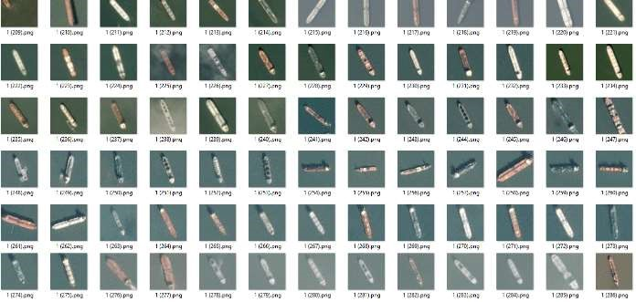

Fig. 5. Ship images sets for training [16].

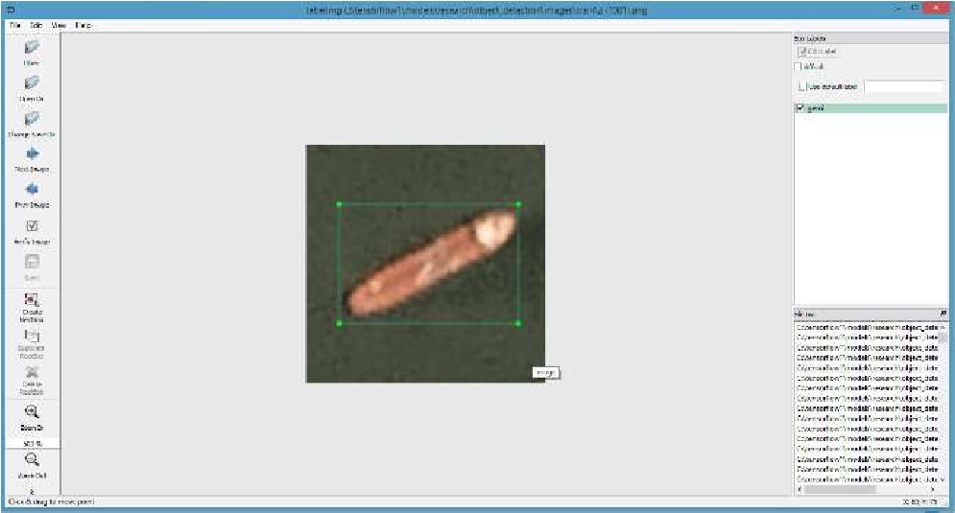

Fig. 6. Labeling images via LabelImg [17].

The training process is checked via loss graphic shown in Fig. 7. The first learning rate value is 0.0002. As the model library is being trained, the loss graph is expected to decrease gradually. If decreasing stops, that means the library stopped to learn or have already learned everything which it can learn. If so, the training can be stopped by the user. For this work, training is stopped at 587800th step (orange).

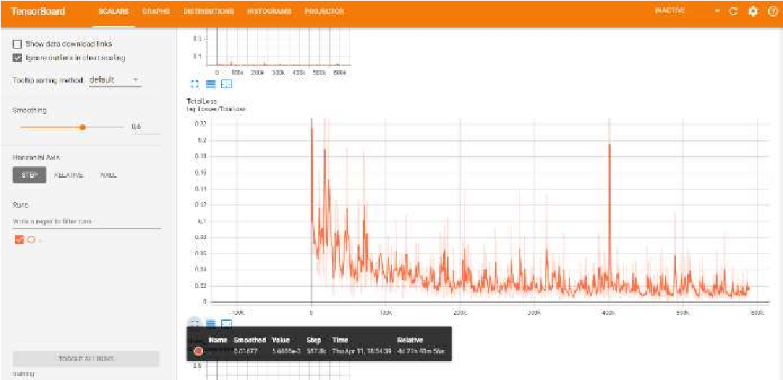

Fig. 7. Tensorboard loss graphic (learning rate: 0.0002).

If the learning rate becomes 0.00002 (10 times smaller), decreasing of the loss graphic becomes slower. Therefore, training is stopped at 195900th step (blue) and ship detection model will be trained with 0.0002 learning rate (orange). Comparison of loss graphics between both learning values is shown in Fig. 8.

The Tensorflow Object Detection Model Zoo was utilised to train the \{Faster R-CNN inception v2_coco model. Google used the Coco Mage Dataset, a sizable item identification, segmentation, and captioning dataset, to train this model. There are several more libraries installed, including "matplotlib, pandas



Fig. 8. Tensorboard loss graphic comparison. (blue: learning rate 0.00002, orange: learning rate 0.0002)

13 satellite images given to the neural network. Information about input images are shown below:

Image 1: Resolution: 550*393*3, RGB band, 96 dpi, 1 ship.

Image 2: Resolution: 265*190*3, RGB band, 96 dpi, 3 ship.

Image 3: Resolution: 577*348*3, RGB band, 96 dpi, 4 ship.

Image 4: Resolution: 246*205*3, RGB band, 96 dpi, 3 ship.

Image 5: Resolution: 261*193*3, RGB band, 96 dpi, 1 ship.

Image 6: Resolution: 313*313*3, RGB band, 96 dpi, 1 ship.

Image 7: Resolution: 1291*799*3, RGB band, 96 dpi, 2 ship. Image 8: Resolution: 1197*1043*3, RGB band, 72 dpi, 1 ship.

Image 9: Resolution: 954*954*3, RGB band, 96 dpi, 6 ship.

Image 10: Resolution: 827*395*3, RGB band, 96 dpi, 5 ship. Image 11: Resolution: 756*402*3, RGB band, 96 dpi, 23 ship.

Image 12: Resolution: 500*200*3, RGB band, 96 dpi, 11 ship.

Image 13: Resolution: 1950*1950*3, RGB band, 96 dpi, 16 ship.

Results are displayed in between Fig. 9 to Fig. 21.

Fig. 9. Detection Result of Image 1. Fig. 13. Detection Result of Image 5.

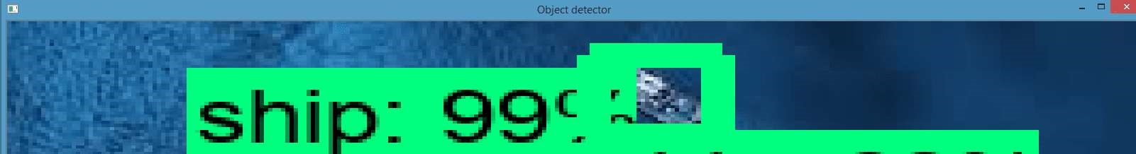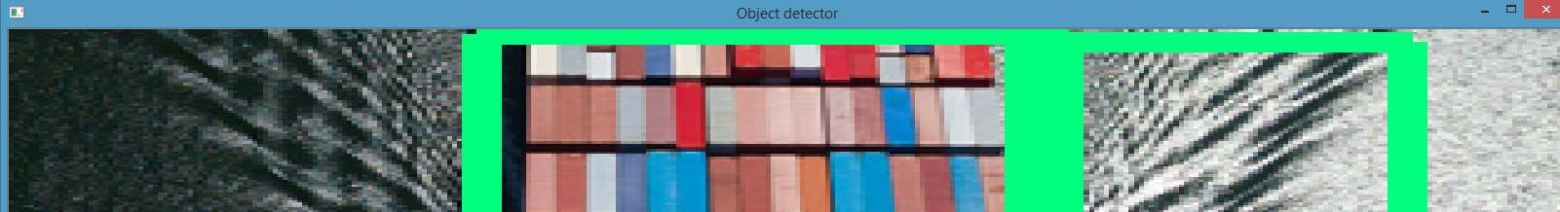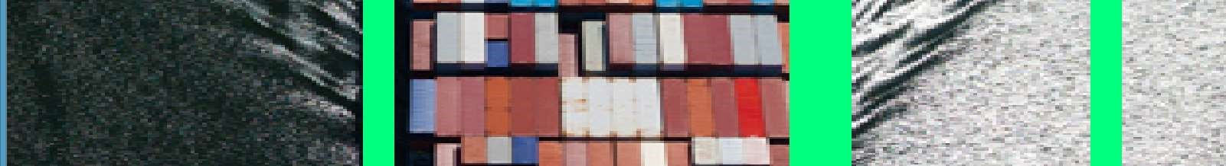

Fig. 10. Detection Result of Image 2. Fig. 14. Detection Result of Image 6.

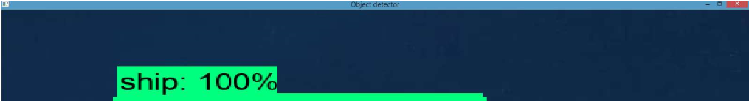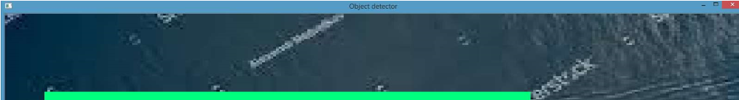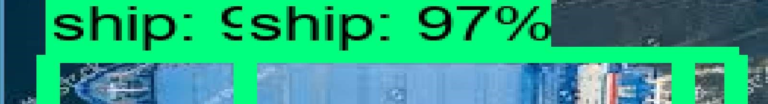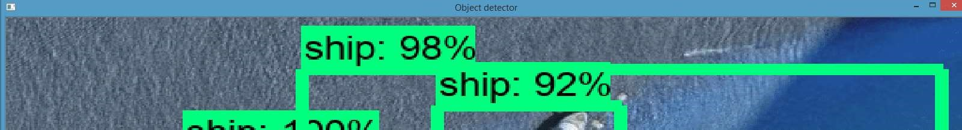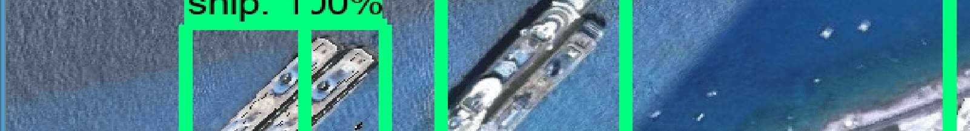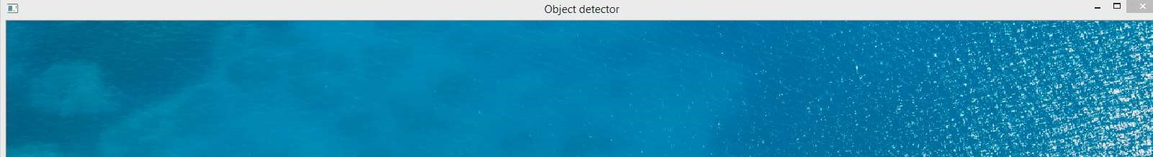

Fig. 11. Detection Result of Image 3. Fig. 15. Detection Result of Image 7.

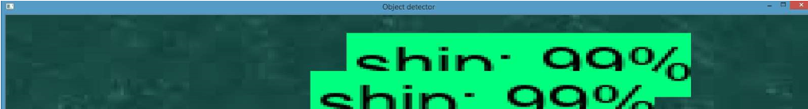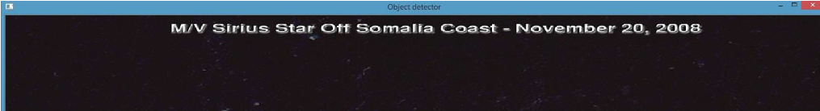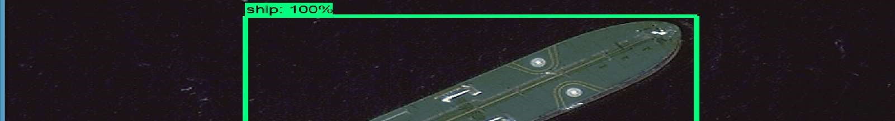

Fig. 12. Detection Result of Image 4. Fig. 16. Detection Result of Image 8.

Fig. 17. Detection Result of Image 9. Fig. 21. Detection Result of Image 13.

The system works properly but has some false alarms with pictures with fewer than six ships. The performance declined as the picture's coverage area or the number of ships rose. Performance can be improved by expanding the library's image count, adding new, higher-resolution photos, repeating the training process using alternative APIs, and combining this system with other detection techniques that have been documented in the literature.

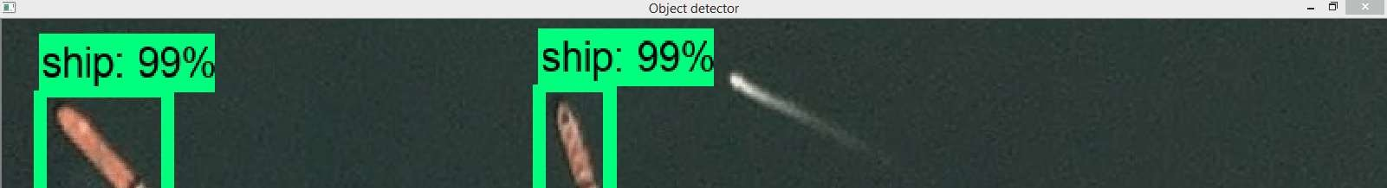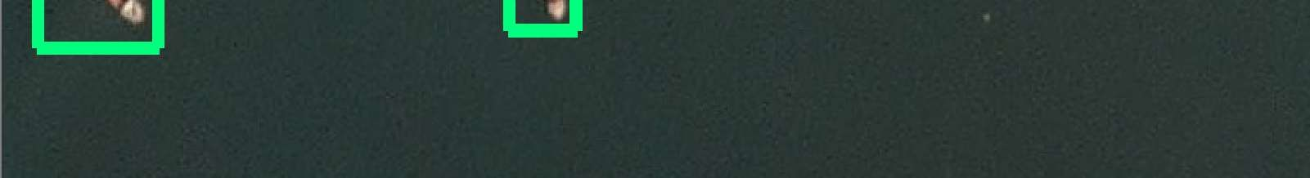

V. CONCLUSION

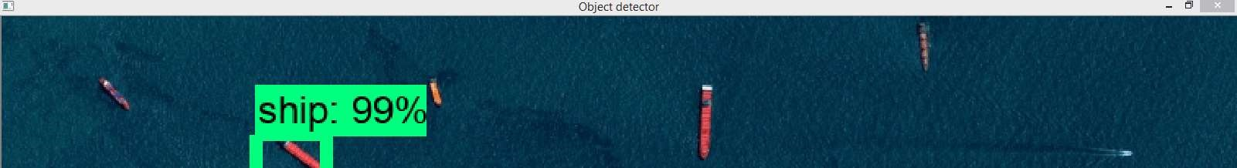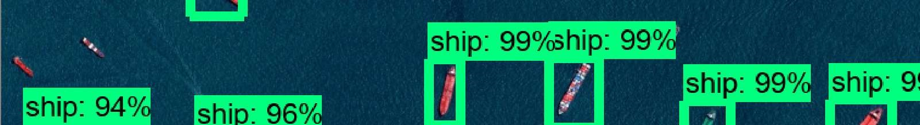

This paper proposed an open source, fast running ship detection system from optical satellite images with the deep learning algorithm. The system does not need any comprehensive hardware, even can work on an average laptop. Tensorflow Object Detection Application Programming Interface (API) is trained by optical satellite images with ships and used as object detection API. As a result, an additional method has been added to the ship detection algorithms by training the Tensorflow Object Detection API. The results are promising for the future. To increase performance, the number of images in the library can be increased, different resolution pictures can be added, the training can be repeated with different APIs and this system can be mixed with other detection methods mentioned in the literature.

Fig. 19. Detection Result of Image 11.

APPENDIX

Python 3.7 is used as the programming language, Tensorflow is used for deep learning, Anaconda is used for Python libraries, and OpenCV is used for computer vision libraries. An artificial neural network called a Faster Region Based Convolutional Neural Network (Faster R-CNN) is employed. It operates far quicker than the traditional R-CNN algorithm. The Tensorflow Object Detection Model Zoo was utilised to train the \{Faster R-CNN inception v2_coco model. Google used the Coco Mage Dataset, a sizable item identification, segmentation, and captioning dataset, to train this model. There are several more libraries installed, including "matplotlib, pandas

**REFERENCES**

1. C. Yaman and V. Asari, "Long-Range Target Classification in a Cluttered Environment Using Multi-Sensor Image Sequences," 2007 3rd International Conference on Recent Advances in Space Technologies, Istanbul, 2007, pp. 304-308.
2. G. Soni, A. Singh and N. Sharma, "Inshore ship and hybrid object detection and recognition using context-aware color and shape model," 2015 International Conference on Control, Instrumentation, Communication and Computational Technologies (ICCICCT), Kumaracoil, 2015, pp. 699-703.
3. N. Rahmani and A. Behrad, "Automatic marine targets detection using features based on Local Gabor Binary Pattern Histogram Sequence," 2011 1st International eConference on Computer and Knowledge Engineering (ICCKE), Mashhad, 2011, pp. 195-201.
4. F. Yang, Q. Xu, F. Gao and L. Hu, "Ship detection from optical satellite images based on visual search mechanism," 2015 IEEE International Geoscience and Remote Sensing Symposium (IGARSS), Milan, 2015, pp. 3679-3682.
5. T. Li, Z. Liu, L. Ran and R. Xie, "An efficient scheme for ship detection in high-resolution TerraSAR-X images," 2016 CIE International Conference on Radar (RADAR), Guangzhou, 2016, pp. 1-4.
6. W. Li et al., "Integrated Localization and Recognition for Inshore Ships in Large Scene Remote Sensing Images," in IEEE Geoscience and Remote Sensing Letters, vol. 14, no. 6, pp. 936-940, June 2017.
7. B. Bebinar, A. Alatan, Inshore ship detection in high resolution satellite images: approximation of harbours using sea-land segmentation, Proc. of SPIE Vol. 9643 96432D-9, 2015.
8. V. F. Arguedas, "Texture-based vessel classifier for electro-optical satellite imagery," 2015 IEEE International Conference on Image Processing (ICIP), Quebec City, QC, 2015, pp. 3866-3870.
9. Zhina Song, Haigang Sui and Yujie Wang, "Automatic ship detection for optical satellite images based on visual attention model and LBP," 2014 IEEE Workshop on Electronics, Computer and Applications, Ottawa, ON, 2014, pp. 722-725.
10. W. Li, B. Zou and L. Zhang, "Ship detection in a large scene SAR image using image uniformity description factor," 2017 SAR in Big Data Era: Models, Methods and Applications (BIGSARDATA),

Beijing, 2017, pp. 1-5.

1. I. Karakaya and Y. Çemtay, "The effect of bant selection to success of artificial neural network in hyperspectral classification, "2017 25th Signal Processing and Communications Applications Conference (SIU), Antalya, 2017, pp. 1-4.
2. W. Shen and W. Wang, "Node Identification in Wireless Network Based on Convolutional Neural Network, "2018 14th International Conference on Computational Intelligence and Security (CIS), Hangzhou, 2018, pp. 238-241.
3. Rhammell, Ships in Satellite Imagery, Kaggle, 29-Jul-2018. [Online]. Available: https://www.kaggle.com/rhammell/ships-insatellite-imagery. [Accessed: 01-Apr-2019].
4. Tzutalin, tzutalin/labelImg, GitHub, 22-Apr-2019. [Online]. Available: https://github.com/tzutalin/labelImg. [Accessed: 01-Apr2019].
5. Rhammell, Ships in Satellite Imagery, Kaggle, 29-Jul-2018. [Online]. Available: https://www.kaggle.com/rhammell/ships-in satellite-imagery. [Accessed: 01-Apr-2019].
6. Tzutalin, tzutalin/labelImg, GitHub, 22-Apr-2019. [Online]. Available: https://github.com/tzutalin/labelImg. [Accessed: 01-Apr 2019]